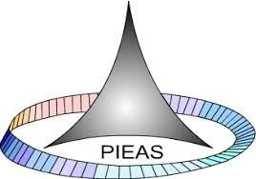

PAKISTAN INSTITUTE OF ENGINEERING AND APPLIED SCIENCES

***Computing Fundamentals & Programming***

**FALL 2020**

Laboratory Exercise-06

Name: Umar Shifaqat

Department: DPAM

Roll No. BS-20-GB-100864

Date: NOV 04, 2020

TASK 01

INPUT

#include<stdio.h>

int main()

{

char alphabet='a';

printf("\n\tThe alphabets from 'a' to 'z' are :\n");

while(alphabet<='z')

{

printf("\n\t%c",alphabet);

alphabet++;

}

getchar();

return 0;

}

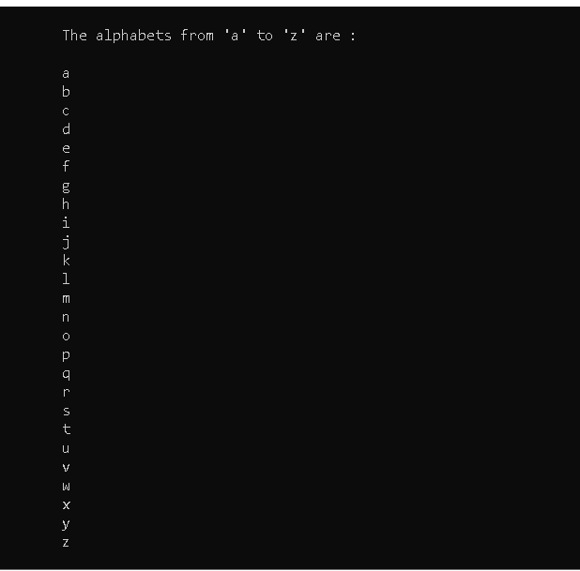

TASK 02

INPUT

#include<stdio.h>

int main()

{

int number,cube,integer,i;

printf("Enter the Number of Terms : ");

scanf("%d",&integer);

printf("\t");

number=1;

while(number<=integer)

{

cube=1;

for(i=1;i<=3;i++)

cube*=number;

printf("The cube of %d is %d.\t\t\t",number,cube);

if(number%2==0)

printf("\n\t");

number++;

}

getchar();

getchar();

return 0;

}

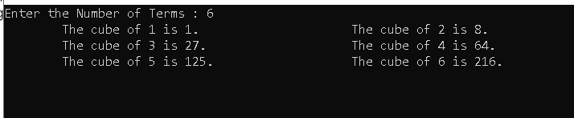

TASK 03

INPUT

#include<stdio.h>

int main()

{

int number,table,integer,i;

printf("\n\tEnter the Table Number starting from 1 : ");

scanf("%d",&integer);

printf("\t\t\t\tMultiplication Table from 1 to %d :\n\n",integer);

number=1;

while(number<=integer)

{

for(i=1;i<=10;i++)

{

table=i*number;

printf("\t%d*%d=%d",number,i,table);

}

printf("\n");

number++;

}

getchar();

getchar();

return 0;

}

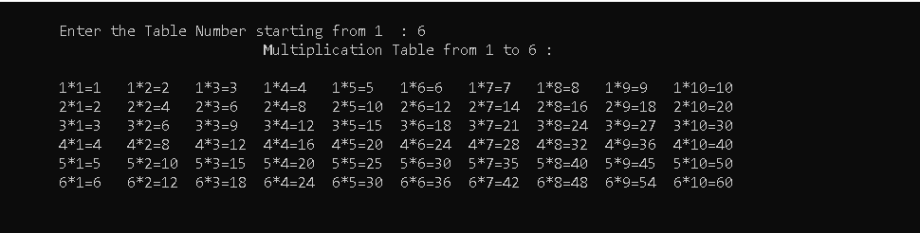

TASK 04

INPUT

#include<stdio.h>

#include<math.h>

int main()

{

int y,n,m,i,factorial;

float X,term,sum=1.0;

printf("\n\tEnter the value of X: ");

scanf("%f",&X);

printf("\n\tEnter the Number of terms: ");

scanf("%d",&n);

for(i=1;i<=n;i++)

{ m=2*i;

factorial=1;

for(y=1;y<=m;y++)

factorial*=y;

term=pow(X,m);

term/=factorial;

if(i%2==1)

term=-term;

sum+=term;

}

printf("\n\t\tSum= %f ",sum);

printf("\n\t\tNumber of Terms = %d \n\t\tValue of X = %f\n",n,X);

getchar();

getchar();

getchar();

return 0;

}

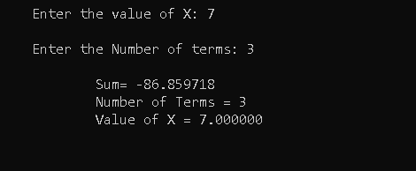

TASK 05

INPUT

#include<stdio.h>

int main()

{

int num1,num2,hcf=1,i,n;

printf("\n\tEnter the numbers to find HCF.\n\t\t number 1: ");

scanf("%d",&num1);

printf("\n\t\tEnter number 2: ");

scanf("%d",&num2);

if(num1<num2)

n=num1;

else

n=num2;

for(i=1;i<=n;i++)

{

if(num1%i==0 && num2%i==0)

hcf=i;

}

printf("\n\n\t\t\tThe HFC of %d and %d is %d",num1,num2,hcf);

getchar();

getchar();

return 0;

}

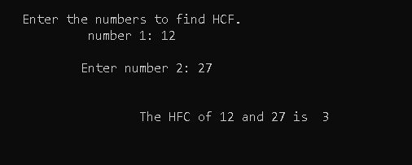

TASK 06

INPUT

#include<stdio.h>

int main()

{

int number,i;

float j,sum=0;

printf("Enter the number: ");

scanf("%d",&number);

printf("\n\t");

for(i=1;i<=number;i++)

{

printf(" 1/%d +",i);

j=1/(float)i;

sum+=j;

}

printf("\b ");

printf("\n\n\tSum of series upto %d terms is %f",number,sum);

getchar();

getchar();

return 0;

}

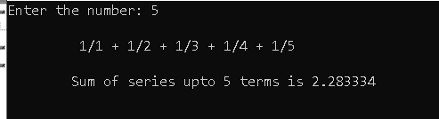

TASK 07

INPUT

#include<stdio.h>

int main()

{

int num,sum=0,x,y,i=1,j,k;

printf("Enter the number : ");

scanf("%d",&num);

while(i<=num)

{

j=1;

x=0;

while(j<=i)

{

y=1;

for (k=2;k<=j;k++)

{

y*=10;

}

x+=9*y;

j++;

}

printf(" %d ",x);

sum+=x;

i++;

}

printf("\n\tThe sum of the series is %d",sum);

getchar();

getchar();

return 0;

}

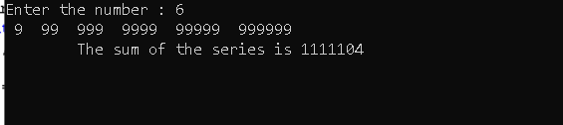

TASK 08

INPUT

#include<stdio.h>

#include<math.h>

int main()

{

int x,n,sum=0,a,b,i,j,k;

printf("Enter the value of x: ");

scanf("%d",&x);

printf("Enter the number of terms: ");

scanf("%d",&n);

printf("The values of the series are : ");

a=1;

for(i=1;i<=n;i++)

{

b=pow(x,a);

a+=2;

if(i%2==0)

b=-b;

printf("\n\t%d",b);

sum+=b;

}

printf("\nThe sum is %d",sum);

getchar();

getchar();

getchar();

return 0;

}

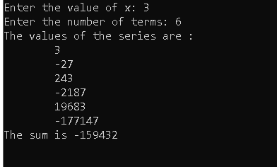

TASK 09

INPUT

#include<stdio.h>

int main()

{

int num,n,sq,sum=0;

printf("Enter number of terms : ");

scanf("%d",&num);

for(n=1;n<=num;n++)

{

sq=n*n;

printf(" %d ",sq);

sum+=sq;

}

printf("\n\n\t\tThe sum of Square Natural Numbers upto %d terms is %d",num,sum);

getchar();

getchar();

getchar();

return 0;

}

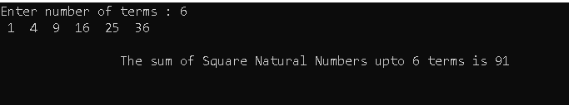

TASK 10

INPUT

#include<stdio.h>

int main()

{

int i,j;

printf("\n\n\t*\n\n\t");

for(i=1;i<=10;i++)

{

for(j=1;j<=i;j++)

{

printf("*****");

}

printf("\n\n\t");

}

getchar();

return 0;

}

